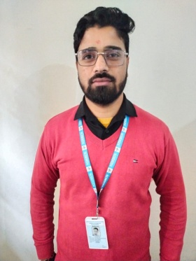
Vinod Dhasmana
Assistant professor in Nimbus School of Education
Area
Primary Area: Education
Secondary Area: Humanities,
Contact: 7895430291
Email: vkd557@gmail.com
Phone: +91-7895430291
Education
• Master of Education, Swami VivekaNand Subharti University Merrut
• Bachelor of Education, Uttrakhand Sanskrit University Haridwar
• Master of Art, Bachelor of Art

Teaching
• Hindi
• Sanskrit
• Language Across the Curriculum

Research Area
Hindi Literature Sanskrit Sahitya

Academic Experience
Faculty Member, Nimbus School of Education, 19 December 2021 onwards.

Professional Experience
Nimbus School of Education

Selected Publications
Shodash Sanskar
Medium of Hindi ,Sanskrit and English Students thinking style and academic achievement

